# Problem 53.2.1

## 

## Answer

The only one way is best in matlab for storing the value/data is second option “two_feet”.

# Problem 53.2.5

## Code

clc

clear all

close all

X=[2 -3 4;1 7 8];

Y=[4 -2;-1 3;2 1];

% A

part_A=X*Y

% B

% part_b=X+Y

% not possible part b because Matrix dimensions not agree.

% c

part_c=X' + Y

% d

part_D=Y*X

## Output

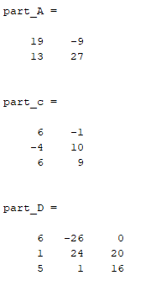

# Problem 54.1.1

## Code

clc

clear all

close all

n=100;

a(1)=0;

a(2)=1;

for i=1:n-2;

a(i+2)=a(i+1)+a(i);

end

semilogy(a)

title ('Fibonacci numbers and ration ')

xlabel ('---n')

ylabel('fib')

hold on

grid

for i=1:n-1;

ratio(i)=a(i+1)/a(i);

end

plot(ratio,'-o')

## Output

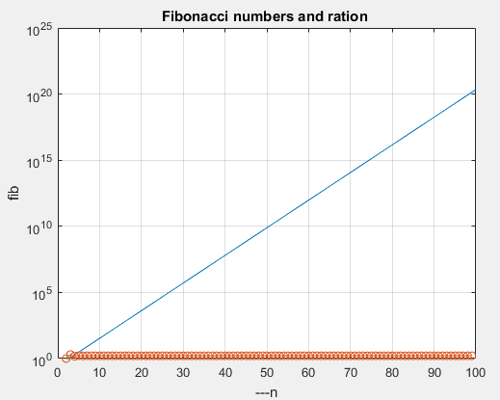

# Problem 54.1.2

## Code

clc

clear all

close all

m=2;

b=[1];

x=[0.01:0.1:100];

y=m.*x + b;

plot(x,y)

grid

hold on

semilogx(x,y);

hold on

semilogy(x,y);

hold on

loglog(x,y);

## Output

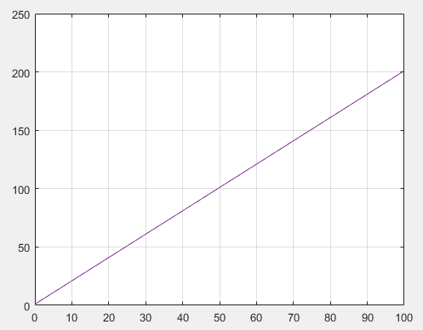

# Problem 54.2.2

## Code

clc

clear all

close all

n=100;

a(1)=0;

a(2)=1;

for i=1:n-2;

a(i+2)=a(i+1)+a(i);

end

for i=1:n-1;

ratio(i)=a(i+1)/a(i);

end

zf(1) = figure(1);clf

za(1) = axes;

zp(1) = semilogy(a);grid

xlabel('n')

ylabel('fib')

title('fibno number ')

set(za(1),'position',[.1 .6 .4 .31])

za(2) = axes;

zp(2) = plot(ratio);grid

xlabel('n')

ylabel('fib ratio')

title('fibno number ratio ')

set(za(2),'position',[.6 .6 .35 .31])

limt=10000;

prime_=primes(limt);

za(1) = axes;

zp(1) = semilogy(prime_);grid

xlabel('n')

ylabel('primes till 10000')

title('primes')

set(za(1),'position',[.1 .18 .35 .31])

for i=1:length(prime_)-1;

ratio(i)=prime_(i+1)/prime_(i);

end

za(2) = axes;

zp(2) = plot(ratio);grid

xlabel('n')

ylabel('prime ratio')

title('prime ratio ')

set(za(2),'position',[.6 .18 .35 .31])

## Output

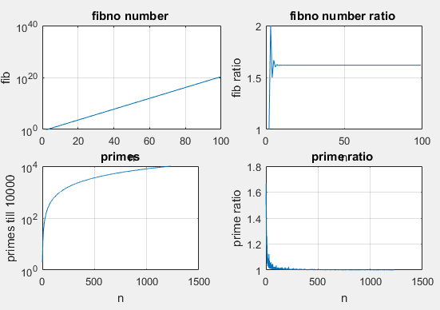

# Problem 54.3.5

## Code

## Output